Abraham Lincoln is honored in American history because of his presidency during the Civil War and his Emancipation Proclamation. These landmark events have garnered Lincoln lasting recognition throughout history in the form of many sculptures and images. Cincinnati, Ohio, has its own monument to Lincoln in the form of George Grey Barnard’s Abraham Lincoln, unveiled in 1917 (Figure 1). The style of Barnard’s statue, the initial commission from Anna and Charles Taft, the statue’s departure from local and national trends, and the controversy over the statue reveal that Cincinnati is defined by patriotism, conservatism, and high moral values. The Lincoln statue is beloved in Cincinnati because it serves as a rallying symbol of democracy by depicting Lincoln as a common man that rose to America’s highest office. The humble portrayal of Lincoln encapsulates his true spirit and the power of the monument rests in the viewer’s ability to feel the character of Lincoln. Despite the lasting adoration for Abraham Lincoln, the monument is very controversial because of the unconventional style. Depicted in a realist style, Abraham Lincoln is beardless and gaunt. Instead of being shown as the nation’s noble President or Commanding General, Lincoln is shown as a homely laborer. The statue is also controversial because Cincinnati is very conservative while Lincoln is shown in a way that creates sympathy for laborers and appeals to liberal ideology. Both the controversy and the praise for Abraham Lincoln, reinforce Cincinnati’s patriotism, conservatism, and high moral values.
Standing at 13.4 feet tall, on a rough granite base, Abraham Lincoln has a monumental presence. The head of Lincoln was the first part of the statue to be completed. To model the head, Barnard used the original life mask of Lincoln, cast by Leonard Volk in 1860. Lincoln’s hair is disheveled and falls slightly over the large ears. Beneath, the broad forehead is marked by wrinkles that meet thick, arched eyebrows. The eyes are inset and the eye lids seem to droop. Below, the nose is prominent and on either side sharp cheek bones highlight sunken cheeks. The lower lip sticks out, casting a shadow on the beardless chin. Taken together these characteristics make Lincoln seem withdrawn in thought and create an expression of frustration. The viewer feels a solemn weight and is pushed to consider what it is that Lincoln is thinking. Barnard chose this depiction because he wanted to show Lincoln as a rail-splitter, before he was President, as “Lincoln of The People.” The face reveals that Lincoln was worn and tired from hard labor and that he was not exempt from worry and pain. These characteristics humble the often immortal image of Lincoln in the common populace.
After the completion of the head, Barnard began to search for a live model for the body. The sculptor wanted to find a man that shared a common history and similar appearance with Lincoln. Charles Thomas was eventually selected as the live model; he was a forty-four-your-old man from Illinois that had been a rail-splitter. The final statue shows that Barnard chose to realistically show the toll hard labor had taken on Thomas. The upper back is hunched and swollen and the hands are weathered with large veins in high relief. The suit appears too small and hangs open over the thighs. In the center of the body the right hand grasps tightly onto the relaxed left hand. At the bottom of the statue, the feet are firmly planted on the ground with the weight distributed evenly between them. These characteristics combine into an awkward, gangly stance. Lincoln appears as a laborer, shaped by hard, physical work. The awkward stance is unimposing and the viewer feels as though Lincoln is someone relatable and mortal.
Abraham Lincoln was also influenced by Barnard’s past. Born in 1863, Barnard was the son of an Indiana preacher, Joseph Barnard who praised socialism and equality for those who labor. Joseph Barnard influenced George Barnard during the creation of Abraham Lincoln. Barnard placed value on the poor and lower class by showing Lincoln as their kin. Socialism and other such liberal ideology were not supported in conservative Cincinnati, so Barnard refrained from sharing his liberal ideology during the creation of the statue. Also, Abraham Lincoln was created late in Barnard’s career. The sculptor spent many years in France where he crafted nude sculptures for progressive and wealthy patrons. Upon his return to America, Barnard had a difficult time assimilating to the American art world. This may be reflected in Abraham Lincoln by the realist style that was more progressive than typical American statues. Barnard’s image of Lincoln was also influenced by the writings of Truman Bartlett, published in 1907, that described Lincoln before his Presidency as an isolated backwoodsman. E.W. Thompson wrote to the Boston Evening Transcript and also implored for artists to, “… save the living Lincoln [for] all future ages – as he appeared to the people of his time …” Abraham Lincoln captures the spirit of Bartlett and Thompson, Barnard felt that he created the true soul of Lincoln. Therefore the viewer should not be absorbed in the physical appearance of the statue but should seek to understand the character of the noble President. Lincoln is depicted as a man of the people which gives hope to those who are labor and toil; they too may one day rise above their struggles. These characteristics give the statue a moral lesson. Finally, the appearance of Lincoln as a laborer indicates that the seat of the President is open to all, which reinforces the ideals of democracy. The democratic ideals and the moral lesson in the statue appealed to the patriotic spirit and high moral values in the Cincinnati community.
The choice to depict Lincoln, instead of an alternative president, also reveals Cincinnati’s conservative political values. Cincinnati once stood as the border between slave states in the south and the Free states in the north. Abolitionists in Cincinnati voiced their dissent towards slavery and played an active role the nation’s politics. Abraham Lincoln symbolizes the victory of freedom over slavery, and in an allegorical sense the victory of good over evil. Lincoln protected the unity of the nation against the separation of the South. Furthermore, Lincoln is credited with the emancipation of American slaves. Cincinnati honor’s Lincoln as a symbol of some conservative values because Lincoln sought to conserve and protect the founding principles of the constitution.
Many citizens from Cincinnati fought in the Civil War, and upon their return home sought to monumentalize their beloved Lincoln. One such soldier was Frederick H. Alms, and upon his death, Eleanora Alms decided to erect a Lincoln statue in her husband’s honor. Eleanora Alms, assisted by Harry Probasco, created a committee to oversee the project that included Charles Taft, brother to President William Howard Taft and local patron. Disagreements between sculptors, and opposing political agendas between Charles Taft and Probasco, resulted in a split between Probasco and Alms with Taft. Eventually Anna and Charles Taft chose to sign an independent contract with Barnard because he was native to American and had received much acclaim for his work in Paris. The desire for the Tafts to commission the Lincoln statue, despite the conflict with Alms and Probasco, shows the passion the Tafts had for Abraham Lincoln. The Tafts were the wealthiest citizens in Cincinnati, they were rooted in strong conservative politics and supported upholding the law and protecting capitalism. The fact that Barnard was an American added patriotic value to the sculpture of Lincoln. Beyond their nationalistic and political beliefs, the Tafts believed it was their moral responsibility to bring culture and art to Cincinnati, a western frontier. The Tafts’ moral beliefs and conservative values motivated them to commission Barnard to create Abraham Lincoln.
The Tafts may also have been motivated to commission a Lincoln statue due to the fact that Charles Taft’s brother, former President William Howard Taft, was chairman of the Lincoln Memorial Commission (LMC) for the District of Columbia. In February 2011, William Taft began the search for an artist to sculpt a great, seated Lincoln for the monument. The artists that the LMC chose as finalists in the competition reveals the national trends in Lincoln statues. Augustus Saint-Gaudens, who died in 1907, was used as a standard for the committee to compare other artists to. Saint-Gaudens was known for his Abraham Lincoln¸ placed in Chicago, Illinois in 1887 (Figure 2). The Chicago Lincoln is over-scale, made in bronze, and depicts Lincoln as a strong orator. Lincoln appears to be stepping forward in front of a chair with one arm holding onto his coat. The Volk cast was also used to model the face of Lincoln, however, Saint-Gaudens added a beard so that Lincoln appeared as he would as President. The chair represents Lincoln as the head of state and was influenced by Neo-classical styles. The face of the Chicago Lincoln appears deep in thought but eyes look directly out so that it appears as though Lincoln is about to give a speech. In addition, the Chicago Lincoln stands on a tall base that has the beginning of many of Lincoln’s most famous speeches. The combined effect of these elements gives Lincoln the air of a confident, noble, leader about to give a speech.
The Chicago Lincoln influenced the LMC when they finally selected Daniel C. French to sculpt Abraham Lincoln in the Lincoln Memorial. French was previously best known for Lincoln, 1909, in Lincoln, Nebraska at the capitol building (Figure 3). The Nebraska Lincoln is also made in bronze, with his head facing the ground and both hands folded together in the center. Behind Lincoln is a large piece of granite that has the Gettysburg Address in-scripted on it. Lincoln appears with a beard and a furrowed brow. French chose to depict Lincoln as though he had just finished the Gettysburg Address. The folded hands and bowed head resemble that of someone at a grave, and the furrowed brow reveals the weight of worry from the Civil War. Taken together, Lincoln appears as a strong President but also with solemn grief and empathy for the life lost in the Civil War.
Barnard’s Abraham Lincoln is similar to the national trends in many ways. The Cincinnati Lincoln is made of bronze and the period dress appears very similar to the Chicago and Nebraska Lincolns. Also, French and Barnard’s statues both reveal a worried look and hands joined along the midline. The worried look was used by both artists to impress upon the viewer that Lincoln was not immune to the weight of his responsibility and the hardships of life. Barnard chose, however, to reveal Lincoln as a worried man before he was President. This makes the viewer feel as though the worry is not about the state of the nation, as in the French Lincoln, but about a personal concern. The Barnard Lincoln is therefore more relatable to the viewer, while the French Lincoln is more awe inspiring because it depicts Lincoln as the nation’s leader taking on the weight of the Civil War. Saint-Gaudens and Barnard’s Lincolns share a separate commonality; both used the Volk cast to model the face. This reveals that both Barnard and Saint-Gaudens wanted to depict Lincoln as he would appear in reality. Saint-Gaudens, however, was uninterested in depicting Lincoln as he was before he became president. The addition of the beard elevates Lincoln from the common man that he was before he became President, to the noble orator and leader shown in the Chicago Lincoln. Barnard chose to keep Lincoln beardless, as he was in the Volk cast, to have the opposite effect. The Cincinnati Lincoln is not elevated with ascribed roles of President, Orator, Leader, or General. Instead, Lincoln is depicted in his most relatable role, a working man. Barnard’s desire not to elevate Lincoln translated literally in his decision to place the Cincinnati Lincoln on a low, rough, granite base instead of the high pedestals used by French and Saint-Gaudens.
The stark contrasts between Abraham Lincoln made by Barnard and the national trends show that Barnard rebelled against the standard. Barnard not only turned away from national trends, he also rebelled against local trends in Cincinnati. In 1887, Charles Niehaus was commissioned to create James A. Garfield, a memorial to former President Garfield, originally located on Vine Street in downtown Cincinnati (Figure 4). Today, the statue stands in Piatt Park. James A. Garfield was a native to Ohio and had humble roots as a canal boat operator and preacher. Later, Garfield was elected to the House of Representatives before becoming President until he was assassinated, making his Presidency the second shortest. The bronze statue shows Garfield standing tall with his right hand holding papers and his left hand held high in exclamation. The right foot steps forward and the President appears to be in the midst of an important speech that commands the attention of the viewer. Garfield is placed high on a formal plinth so that the viewer looks up at him.
At the opposite end of Piatt Park stands William Henry Harrison, by Louis T. Rebisso, unveiled in 1896 (Figure 5). William Henry Harrison came to Cincinnati, Ohio at the age of eighteen and enrolled in the United States Army where he gained fame as an Indian fighter. Therefore, Cincinnatians were exuberant when Harrison became President before his tragic death thirty-one days after becoming President. Cincinnatians felt that Harrison’s rise to Presidency brought recognition to the city. The bronze, equestrian statue depicts Harrison during his time in the army before he was President. Harrison appears young and full of life and vigor. He is shown wearing a military uniform with a plumed hat. Both of Harrison’s hands grasp the reins and the horse is shown with its left leg elevated. This shows that Harrison was wounded in battle. The Harrison monument gives the viewer a sense of military might and power. Harrison appears to be taking charge and advancing the territory of the United States. Like the Garfield monument, Harrison is also elevated high on a formal plinth creating a vertical separation between the viewer and the former President.
Harrison, a native to Cincinnati, and Garfield, a native to Ohio, were beloved in Cincinnati because they legitimized the former western frontier city on a national stage. Cincinnatians felt that both presidents honored their home state and highlighted Cincinnati on a national stage. The Presidents brought debates and a buzz of political activity to the city. Cincinnati had an even stronger sentiment for the Presidents because both died while serving their nation in term. Furthermore, both statues were commissioned by a public fund that reveals the dedication of the city to their completion. Altogether, the Garfield and Harrison monument show Cincinnati’s patriotism. William Henry Harrison and James A. Garfield command awe and respect, they appear noble and elite in the traditional neoclassical style. This effect is exaggerated by their elevation on a traditional pedestal. The style of Garfield and Harrison’s statues are similar to the traditional style of representing political and military leaders. Cincinnati has strong conservative values and this is shown in the way both statues conserved the traditions of the past.
Abraham Lincoln shows that Barnard carried on some traditions set by William Henry Harrison and James A. Garfield. The Lincoln statue is also a presidential statue made in bronze. Beyond these surface details, all three statues were made by artists living in America. This reveals that Cincinnati has pride in American artists and wanted to invest in American culture. Furthermore, all three statues are located in public spaces and are meant to inspire the common viewer. Piatt Park and Lytle Park are located in the heart of downtown Cincinnati and attract many visitors. These locations allow the ideals represented by each statue to be spread by many who pass by. Those who commissioned the statue valued sharing moral values with the city at large. In addition Lincoln, Garfield, and Harrison all came from humble beginnings and rose to become President. Despite this commonality, Abraham Lincoln departs from the standards set by Rebisso and Niehaus. The most obvious feature is that the Lincoln statue is not elevated. This reveals that the statue is meant to be more accessible to the viewer to represent Lincoln’s desire to be accessible to the people. In addition, Lincoln is portrayed without any reference to his leadership roles. In contrast, Garfield is presented as President and Harrison as General in the Army. Barnard’s radicle departure may have been made possible because Abraham Lincoln was commissioned by private funds from the Tafts, and William Henry Harrison and James A. Garfield were paid for by public funds. Private funding allowed Barnard to shape Lincoln without the direct input from the Cincinnati community, however, the statue was placed in a public place for the public to view, so the public’s reaction was imperative to Abraham Lincoln’s success.
Private funding distinguishes Abraham Lincoln from the Garfield and Harrison monuments; however, the Lincoln statue was not the first privately funded gift to Cincinnati. In 1871, Henry Probasco donated the Tyler Davidson Fountain, designed by August Von Kreling, now located in Fountain Square (Figure 6). The fountain was constructed entirely of bronze and was designed, made, and assembled abroad in Germany. The fountain features on the very top the “Genius of Water”, with beautiful flowing hair and dress. The idealized, serene figure pours out water from the palms of her lifted hands. Below figures assemble to show realistic forms of common people using water and reaping its benefits. The four corners of the fountain have water fountains that pour out chilled water. Therefore the fountain not only shows the benefits of water, but also allows the viewer to experience them first hand. The large population of German immigrants in Cincinnati were able to appreciate the foreign fountain because it was from their homeland. The conservative Cincinnati population also welcomed the statue because realistic uses of water were depicted instead of pagan gods and foreign kings. In addition, the statue was intended to lessen the amount of alcohol consumed by giving a free source of chilled water for the community. This aspect greatly appealed to those in Cincinnati that wanted to raise the moral values of the community.
Anna and Charles Taft followed in Henry Probasco’s footsteps when they commissioned Abraham Lincoln. Both the fountain and the Lincoln statue were commissioned by wealthy donors that wanted to make a lasting donation to the people of Cincinnati. Due to this desire, the Lincoln statue and the fountain were placed in locations where many people would pass by to appreciate and learn from them. The Tyler Davidson Fountain teaches about pouring out blessings to the community at large in both practical ways and also through gifts. The fountain also places emphasis on the importance of hard work and the value of labor. Abraham Lincoln continues on the moral lesson in the value of labor. Lincoln teaches those around him that the common man who labors and toils is an important member of society that can one day rise to the office of the President. Both the fountain and Lincoln are also over-scale pieces that depict most figures in a realistic way. In the case of the Tyler Davidson Fountain, however, common people are shown realistically while in Abraham Lincoln a President is shown realistically. The realism in Abraham Lincoln was less appreciated because some people believed that it was not appropriate to portray the former President as a laborer and commoner. In contrast, others believed that it was appropriate for Lincoln to be shown in a realistic way because Lincoln was a man of and for the people. In contrast, the Genius of Water is raised high and is shown in an idealized form. The Genius is beautiful, without flaw or blemish, while Lincoln is shown awkward and ugly. Abraham Lincoln is also distinct from the fountain because the statue was designed and created by an American while the Tyler Davidson Fountain design and creation is entirely foreign. Fredrick Moffatt elucidates in Errant Bronzes: George Grey Barnard's Statues of Abraham Lincoln that, “The fountain’s social message failed to mitigate the hard evidence it present of America’s and Cincinnati’s woeful lag behind Europe in the production of arts and crafts. National greatness and regional supremacy would arrive only when native artists could model, carve, and cast as well as, if not better than [their foreign counterparts]…” The Lincoln statue succeeded where the Tyler Davidson Fountain had failed, to create local pride in American talent.
The public was first able to view Barnard’s Abraham Lincoln in a temporary exhibition in New York City, New York on the grounds of Union Theological Seminary from December 8, 1916 to February 16, 1917. During the duration of the exhibition the press covered thee event and a total of 9,000 people visited the statue, the most notable being Theodore Roosevelt. At first Abraham Lincoln was heaped with accolades. Many saw the unusual appearance of Lincoln as a triumph. Those in attendance who appreciated realism and abstraction were willing to look for the meaning behind the unattractive appearance of Lincoln for the deeper lesson within. The North American Review published an article stating that, “The eyes and brows are aglow with benevolence and pity. The large hands folded across his torso (the target for the casual critic) express the innate modesty of the man, the self-forgetfulness which is the model for all of us.” The willingness to look beyond the surface level appearance to the meaning within was a vital part of the viewing experience. It may have been to Abraham Lincoln’s advantage to first be revealed in New York, which compared to Cincinnati, was much more progressive and therefore willing to accept Barnard’s unique conception.
In spite of the praise the statue first received, public outcry was not far behind. The Literary Digest published a photograph of Abraham Lincoln from an unattractive angle that depicted the statue with unrealistic proportions. In the picture, the hands and feet appear especially large and the chin appears very small beneath a massive forehead. When Barnard discovered the article he demanded a retraction, however, the image had already spread across the country. Critics declared that the sculpture looked nothing like the original Lincoln and found great offensive in the manipulation of his figure. Robert Todd Lincoln, the son of Abraham Lincoln wrote a letter, published later in The American Magazine of Art, that described the statue of his father as, “A monstrous figure which is grotesque as a likeness of President Lincoln and defamatory as an effigy.” The common portrayal of President Lincoln greatly undermined the lasting impact and sacrifices that he made for the nation. In light of the controversy already stirring, Abraham Lincoln arrived in Cincinnati as a celebrity whose future community was eager to judge.
On March 31, 1917 Abraham Lincoln was unveiled to an eager and packed crowd in Lytle Park. This day also marked President Woodrow Wilson’s declaration of war on Germany. America’s entrance into the war created a new lens to view the statue of Lincoln. Former President William Howard Taft gave the dedication speech and used the opportunity to find hope in the story of Lincoln for the crowd’s present situation. Lincoln’s history as a defender of democracy was used to support America’s advancement into the war against the opponents of freedom. Others, however, could have identified with the portrayal of Lincoln as a laborer and viewed the war as a class war in which America could defend the rights of the poor and the powerless. In both views, Abraham Lincoln served as a patriotic rallying point for the Cincinnati community.
There were others in the crowd that were less enthusiastic. The more conservative citizens in Cincinnati found the new and radical portrayal of Lincoln to be an insult to the national image of Cincinnati. The hands and feet were too big and the clothes too small for any respectable man. The conservative nature of Cincinnati wanted to follow in the defined standards of traditional sculpture on a pedestal that showed Lincoln as a great leader. Instead, Barnard had made Cincinnati a progressive departure from tradition in his unique depicture of Lincoln. The strongest dissenter was Fredrick W. Ruckstull, the editor of Art World. Ruckstull reprinted the image of Abraham Lincoln from the Literary Digest article side by side with painted portraits of Lincoln. Ruckstull chose images that starkly contrasted the image of Abraham Lincoln to show the reader that the Cincinnati Lincoln was an abomination. Ruckstull believed that Lincoln, “…was above all a six-foot, fighting reformer, so that if we wish to make a statue of him that will exert any psychological power over the majority we must represent him as a noble powerful fighter…but not as a hectic, anemic, weak-kneed slouch.” Ruckstull believed that the root of the issue was that Barnard was an anarchist and sympathizer of the Russian revolution. This assumption would explain why Barnard had portrayed Lincoln as a laborer, to be a direct insult against American democracy. Yet, there were others in Cincinnati that had a different view. The large hands in the statue were the hands of hard work and dedication, the big feet were needed for Lincoln to remain sturdy in his beliefs. The small coat shows that Lincoln was not materialistic and valued character more than possessions. These beliefs allowed viewers to find a moral lesson in Abraham Lincoln. The strongest proponent was Mary Fanton Roberts from the magazine Touchstone. Roberts printed a passionate retort to dissenters stating, “Personally we have always loved to think of Lincoln as a man of the very humble people, whose hands must have stretched a little in forty year’s hard work, who must have had tragedy in his face after being the center of conflict in the Civil War, a man who achieved greatness without losing simplicity, who suffered without losing a sense of humor, who must have been toil worn and care-racked before his death.” Abraham Lincoln conveyed more to the spirit of the viewer, than just to the eyes.
Amidst the controversy raging, Charles and Anna Taft planned to send replications of Abraham Lincoln to Paris, France and London, England Robert Lincoln, a stark opponent to the statue, intercepted this plan. Robert Lincoln, although he had never seen the statue in person, felt that the statue did not resemble Abraham Lincoln and therefore was an insult to his memory. While the statue may be hideous to some, the American public might be able to look past that to the story within. A foreign country, however, would be less familiar with history of Abraham Lincoln and thus would only see the physical deformities. This would create a negative light not only to the memory of Abraham Lincoln, but also to America in general during a time of war when American needed to appear strong and confident. Ruckstull commented on the debate stating that, “If the normal nation has condemned Barnard’s bronze, this is the greatest proof that it is a crime against the nation; it will be a double crime to set up two such bronze hoboes in London and Paris and dub them ‘Lincoln.’” In light of Robert Lincoln’s powerful voice, and the controversy that already existed, the Tafts were unable to send replicas to France or Russia. Instead, the replicas were sent to Manchester, England, in 1919, and to Louisville, Kentucky, in 1922. Robert Lincoln and the Tafts were both motivated by patriotism, Robert Lincoln to save the image of America and the Tafts to spread the hope of democracy abroad.
The controversy between the Tafts and Robert Lincoln exemplifies the idea that defining values can be acted out in polarizing ways. The Cincinnati community is defined by patriotism, conservatism, and the desire to uphold high moral values. These core beliefs unite the common populace but were shown in a variety of ways throughout the design, commissioning, and reactions to Abraham Lincoln. Lincoln’s depiction as a common man continues to inspire a deep love for current Cincinnati citizens. That Lincoln, our nation’s beloved President, could overcome the burdens of labor and worry is still a relatable lesson to the modern viewer. The big hands and bigger feet, however, remain an awkward depiction to some. The viewer is still challenged to understand why the president, general, and emancipator was shown as an awkward, gangly laborer. The controversy engages the public and challenges them to form an opinion of Abraham Lincoln. Both those who appreciate the statue and those who despise it form these opinions based on their shared values. Due to the statue’s fame, Abraham Lincoln has become a symbol of Cincinnati and proves that George Grey Barnard alongside Anna and Charles Taft left a lasting impact on the Cincinnati community.

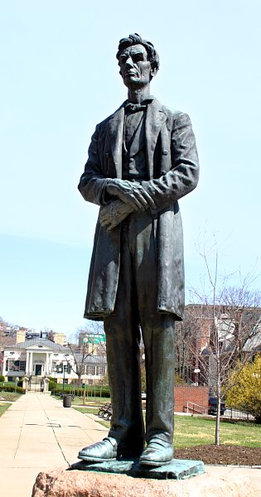
Figure 1. George Grey Barnard, Abraham Lincoln, 1917. Bronze, 13’4”. Cincinnati, Ohio, United States. Available from: Rick Dikeman via Wikimedia Commons, Creative Commons Domain.
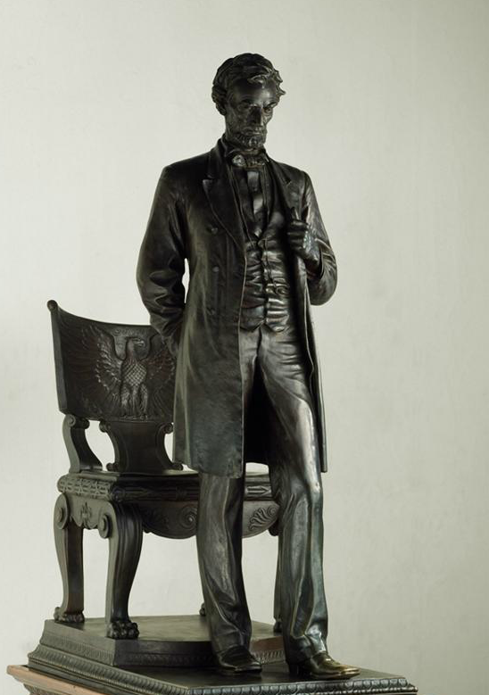
Figure 2. Augustus Saint-Gaudens, Abraham Lincoln, 1887. Bronze, 12’. Chicago, Illinois. Available from: ARTstor.
Figure 3. Daniel C. French, Lincoln, 1909. Bronze, 8’7”. Lincoln, Nebraska. Available from: ARTstor.
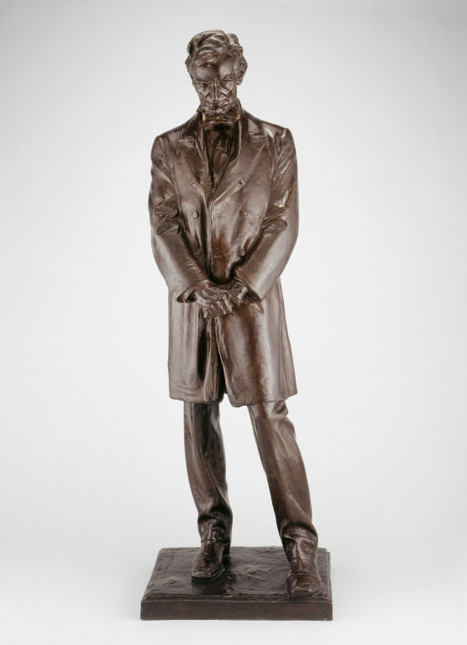

Figure 4. Charles Niehaus, James A. Garfield, 1887. Bronze, 12’. Cincinnati, Ohio. Available from: ARTstor.

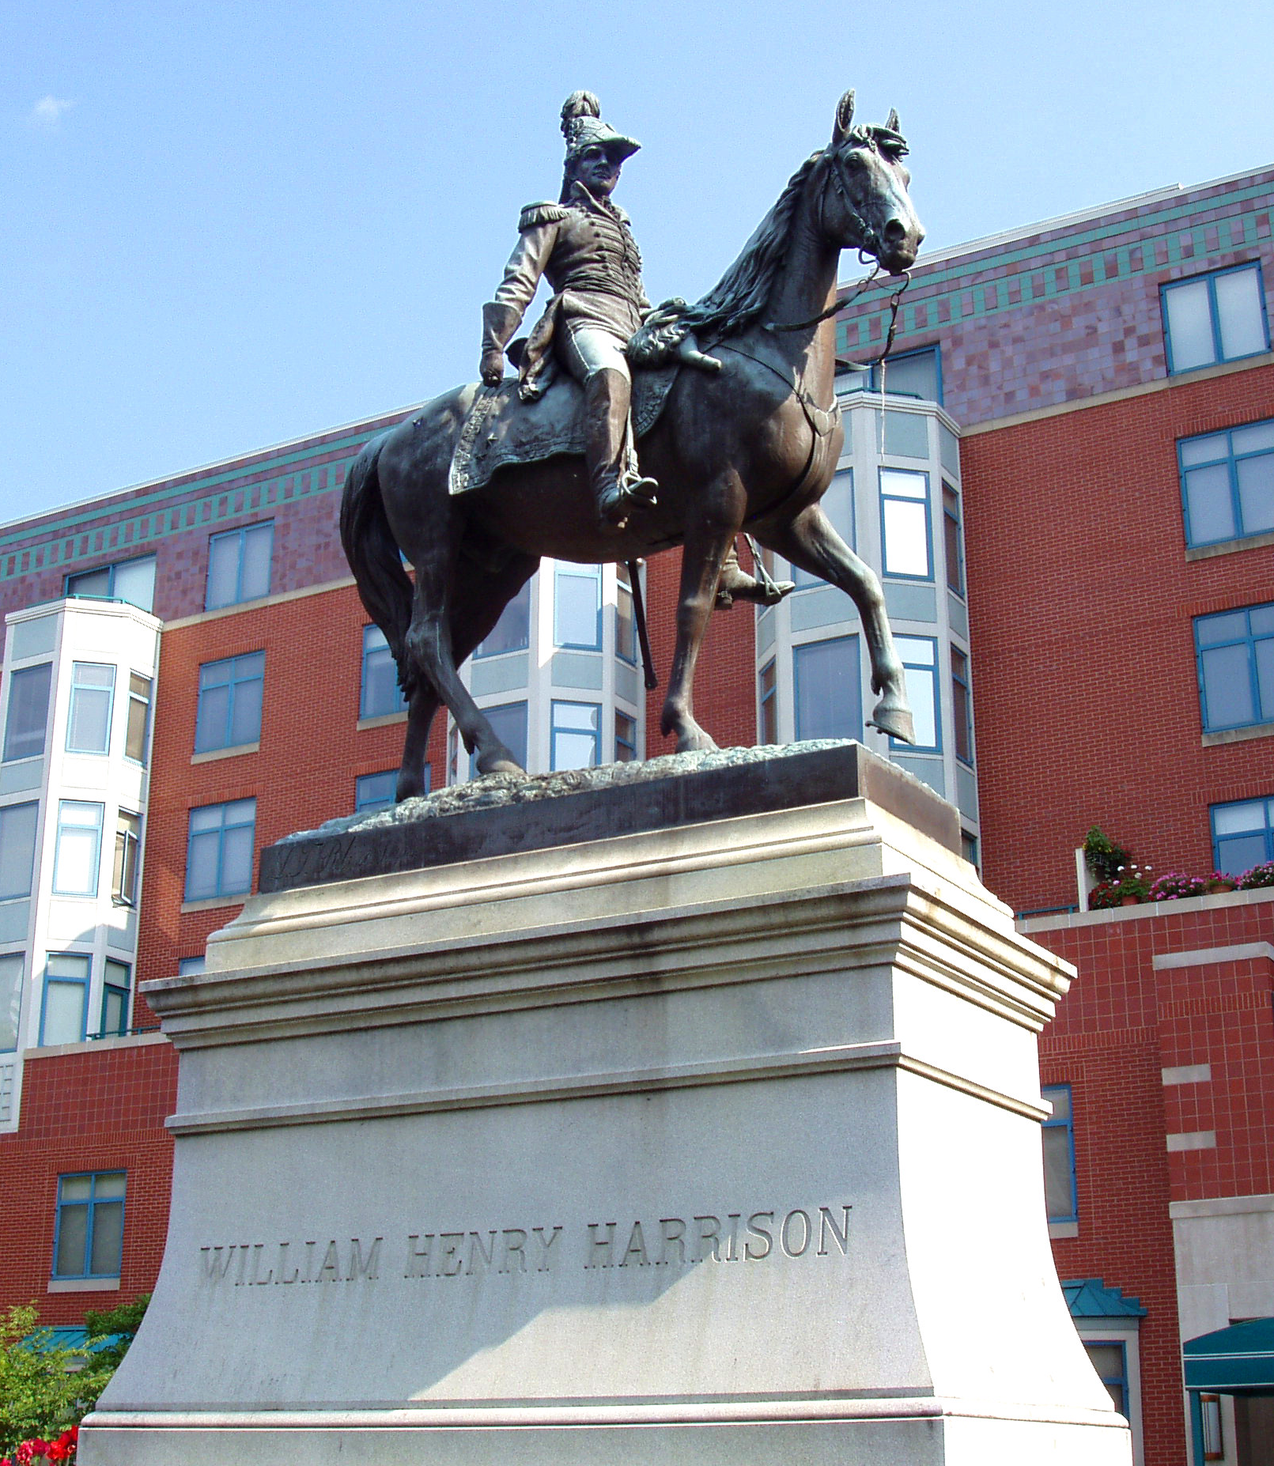
Figure 5. Louis T. Rebisso, William Henry Harrison, 1896. Bronze, 14’. Cincinnati, Ohio. Available from: Rick Dikeman via Wikimedia Commons, Creative Commons Domain.

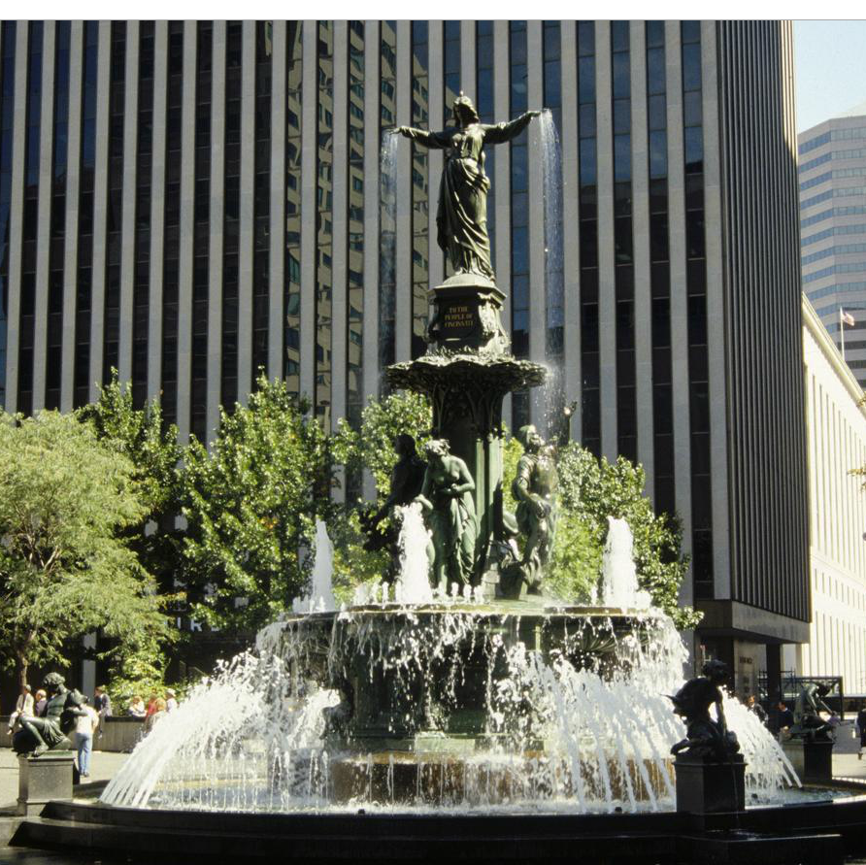
Figure 6. August Von Kreling, Tyler Davidson Fountain, 1871. Bronze, 43’. Cincinnati, Ohio. Available from: ARTstor.

Bibliography
Bartlett, Truman H. “The Physiognomy of Lincoln.” McClure’s Magazine 29 (1907): 391-407.
Clubbe, John. Cincinnati Observed: Architecture and History. Columbus, OH: Ohio State University Press, 1992.
Dickson, Harold. “George Grey Barnard's Controversial Lincoln.” Art Journal 27 (1966): 8–23.
MacMonnies, Frederick. “Barnard’s Lincoln.” North American Review 206 (1917): 837-839.
Mechlin, Leila. “The Barnard Lincoln.” The American Magazine of Art 9 (1917): 72.
Moffatt, Frederick C. Errant Bronzes: George Grey Barnard's Statues of Abraham Lincoln. Newark, DE: University of Delaware Press, 1998.
Roberts, Mary Fanton. “Lincoln, Soul and Body of Democracy – As Shown in the Barnard Statue.” Touchstone 2, no. 2 (1917): 194.
Ruckstull, Frederick Wellington. “A Mistake in Bronze.” The Art World 2, no. 3 (1917): 211.
Ruckstull, Frederick Wellington. “How to Give Europe a Worthy Lincoln Monument.” The Art World 3, no. 4 (1918): 277.
Taft, William H. Barnard's Lincoln, the Gift of Mr. and Mrs. Charles P. Taft to the City of Cincinnati; The Creation and Dedication of George Grey Barnard's Statue of Abraham Lincoln, Including the Address of William Howard Taft. Cincinnati, OH: Stewart and Kidd Company, 1917.
Thompson, E.W. “Letter to the Editor.” Boston Evening Transcript (Boston, MA), March 16, 1899.
U.S. Congress. Senate. Lincoln Memorial Commission Report. 62d Congress, 3de session, 1912. Senate document 965.

Frederick C. Moffatt, Errant Bronzes: George Grey Barnard’s Statues of Abraham Lincoln (Newark, DE: University of Delaware Press, 1998), 7.
Ibid.
Moffatt, Errant Bronzes: George Barnard, 84.
Ibid., 86.
Ibid., 78,
William H. Taft, Barnard's Lincoln, the Gift of Mr. and Mrs. Charles P. Taft to the City of Cincinnati; The Creation and Dedication of George Grey Barnard's Statue of Abraham Lincoln, Including the Address of William Howard Taft (Cincinnati, OH: Stewart and Kidd Company, 1917), 26.
Ibid., 27.
Moffatt, Errant Bronzes: George Barnard, 55.
Ibid., 56.
Ibid., 63.
Ibid., 66.
Truman H. Bartlett, “The Physiognomy of Lincoln,” McClure’s Magazine 29 (1907): 394.
E. W. Thompson, “Letter to the Editor,” Boston Evening Transcript (Boston, MA), March 16, 1899.
Taft, Barnard’s Lincoln, the Gift, 26.
Moffatt, Errant Bronzes: George Barnard, 20.
Taft, Barnard’s Lincoln, the Gift, 39.
Moffatt, Errant Bronzes: George Barnard, 46.
Harold Dickson, “George Grey Barnard’s Controversial Lincoln,” Art Journal 27 (1966): 8.
Dickson, “George Grey Barnard’s Lincoln,” 10.
Moffatt, Errant Bronzes: George Barnard, 51.
Ibid., 37.
U.S. Congress, Senate, Lincoln Memorial Commission Report, 62d Congress, 3de session, 1912. Senate document 965.
Moffatt, Errant Bronzes: George Barnard, 24.
Moffatt, Errant Bronzes: George Barnard, 26.
Ibid., 27.
Ibid., 26.
Ibid.
Ibid., 28.
Ibid., 30.
Ibid.
Moffatt, Errant Bronzes: George Barnard, 84.
John Clubbe, Cincinnati Observed: Architecture and History (Columbus, OH: Ohio State University Press, 1992), 62.
Ibid.
Ibid.
Clubbe, Cincinnati Observed: Architecture and History, 45.
Ibid.
Ibid.
Ibid.
Clubbe, Cincinnati Observed: Architecture and History, 45.
Ibid.
Ibid.
Taft, Barnard’s Lincoln, the Gift, 55.
Clubbe, Cincinnati Observed: Architecture and History, 45.
Ibid., 13.
Ibid.
Clubbe, Cincinnati Observed: Architecture and History, 13.
Ibid.
Moffatt, Errant Bronzes: George Barnard, 51.
Taft, Barnard’s Lincoln, the Gift, 21.
Moffatt, Errant Bronzes: George Barnard, 150.
Ibid., 153.
Ibid., 40
Ibid., 97.
Moffatt, Errant Bronzes: George Barnard, 97.
Frederick MacMonnies, “Barnard’s Lincoln,” North American Review Magazine 206 (1917): 837.
Moffatt, Errant Bronzes: George Barnard, 100.
Ibid.
Leila Mechlin, “The Barnard Lincoln,” The American Magazine of Art 9 (1917): 72.
Taft, Barnard’s Lincoln, the Gift, 10.
Ibid.
Ibid.
Moffatt, Errant Bronzes: George Barnard, 150.
Moffatt, Errant Bronzes: George Barnard, 149.
Frederick Wellington Ruckstull, “A Mistake in Bronze,” The Art World 2, no. 3 (1917): 211.
Ibid.
Taft, Barnard’s Lincoln, the Gift, 152.
Moffatt, Errant Bronzes: George Barnard, 152.
Mary Fanton Roberts, “Lincoln, Soul and Body of Democracy – As Shown in the Barnard Statue,” Touchstone 2, no. 2 (1917): 194.
Moffatt, Errant Bronzes: George Barnard, 33.
Dickson, “George Grey Barnard’s Lincoln,” 13.
Frederick Wellington Ruckstull, “How to Give Europe a Worthy Lincoln Monument,” The Art World 3, no. 4 (1918): 277.
Dickson, “George Grey Barnard’s Lincoln,” 15.

